**SPRINT-4**

|  |  |
| --- | --- |
| **Date** | 19 NOVEMBER 2022 |
| **Team ID** | PNT2022TMID36291 |
| **Project Name** | SMART SOLUTIONS FOR RAILWAYS |

**PROCEDURE:**

Step1: Develop a node red application for GPS

Step2: Develop a python code for GPS

Step3: Run the program

Step4: Train location will be displayed

Step5:Create a node red for wakeup call and E-catering serice

**NODE RED FLOW:**

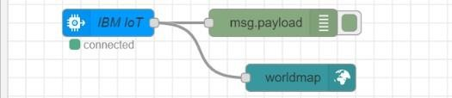

**PYTHON CODE FOR GPS:**

import wiotp.sdk.device import time import random myConfig = {

"identity": {

"orgId": "dks66l",

"typeId": "Sudha",

"deviceId":"45"

},

"auth": {

"token": "sudha2002@"

}

}

def myCommandCallback (cmd): print ("Message received from IBM IoT Platform:

%s" % cmd.data['command'])

m=cmd.data['command']

client = wiotp.sdk.device.DeviceClient(config=myConfig, logHandlers=None) client.connect()

def pub (data):

client.publishEvent(eventId="status", msgFormat="json", data=myData, qos=0, onPublish=None) print ("Published data Successfully: %s", myData)

while True:

myData={'name': 'Train1', 'lat':13.08363 , 'lon': 80.27080} pub (myData) time.sleep (2)

myData={'name': 'Train2', 'lat': 12.40797, 'lon': 79.81410}

pub (myData) time.sleep (2) myData={'name': 'Train1', 'lat': 11.83331, 'lon': 79.37465}

pub(myData) time.sleep(6)

myData={'name': 'Train1', 'lat': 11.59664, 'lon': 78.69899}

pub (myData) time.sleep (6) myData={'name': 'Train1', 'lat': 11.63431, 'lon': 78.11122}

pub (myData) time.sleep (6) myData={'name': 'Train1', 'lat': 11.32207, 'lon': 77.61684}

pub (myData) time.sleep (6) myData={'name': 'Train1', 'lat': 11.03107, 'lon': 76.96864} pub (myData) time.sleep (6) client.commandCallback = myCommandCallback

client.disconnect ()

**PYTHON CODE OUTPUT:**

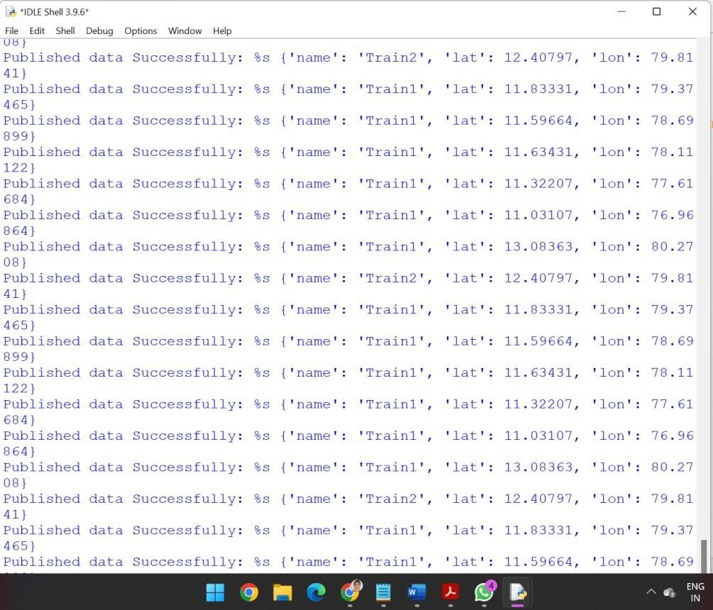

**NODE RED OUTPUT:**

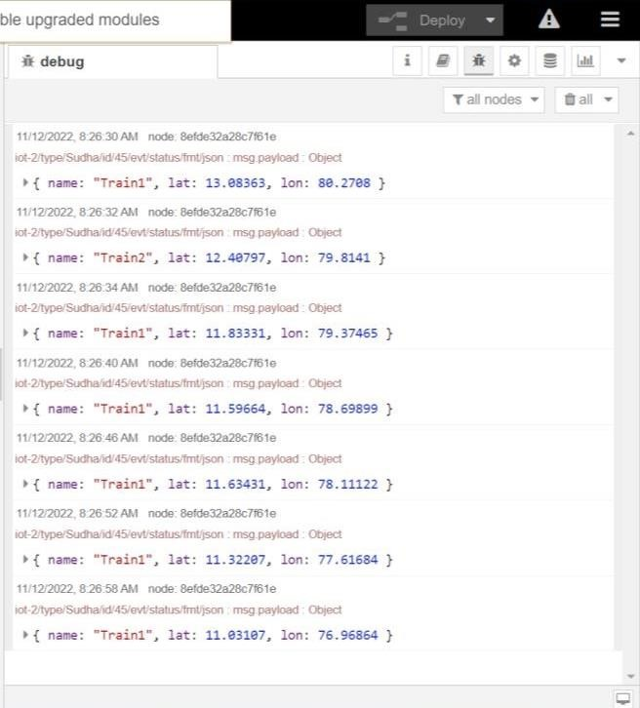

**TRAIN TRACKING :**

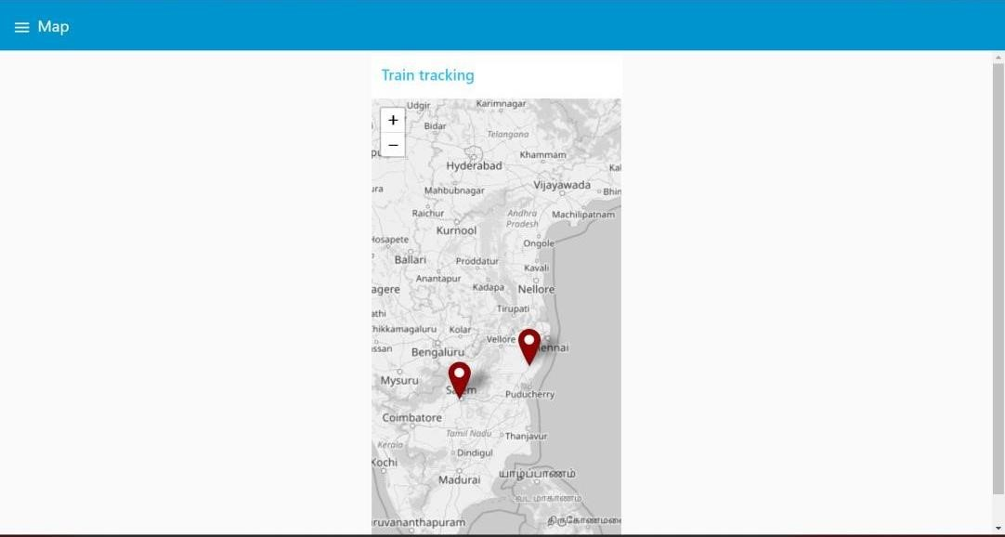

**NODE RED CONNECTION FOR WAKEUP CALL AND E-CATERING SERVICE:**

